

**ACCESSING THE ATLANTA JOURNAL-CONSTITUTION ON YOUR IPAD**

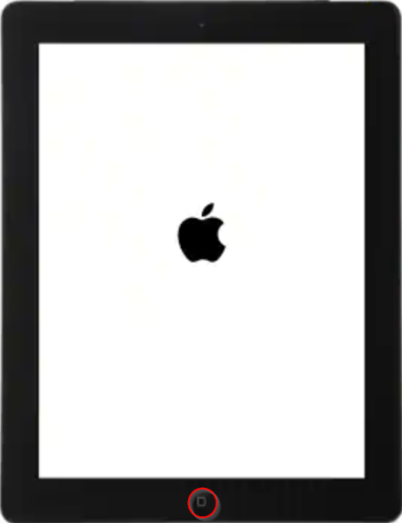 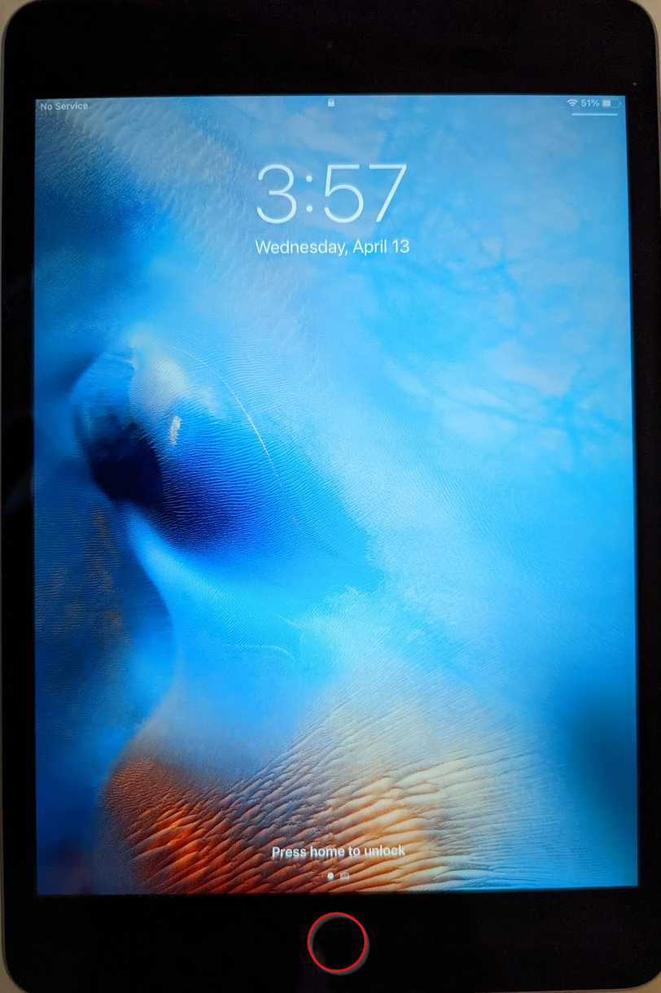

When the screen lights up, press the **HOME** button again to open the home screen.

Press the **HOME** button on the bottom of your iPad.

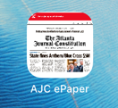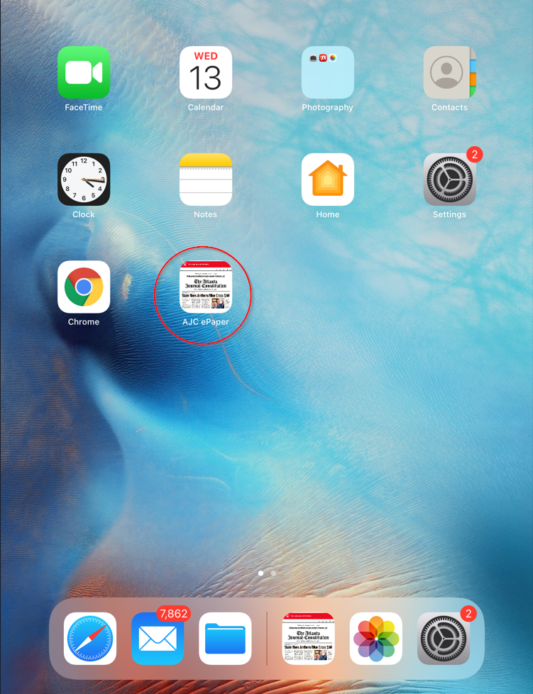

With the screen on, tap the AJC ePaper icon to open the ePaper.

**TURNING iPAD ON/OFF**

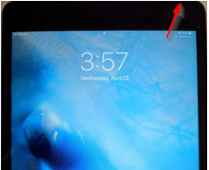

To turn the iPad completely off, or turn it on after being shut down, press and hold the button on the top right corner of the iPad, then follow the instructions to complete the on/off.

**COMPLETELY CLOSE AN APP ON THE iPAD**

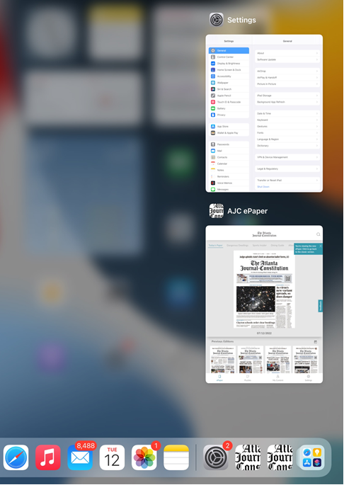

Starting on the black bar below the screen, press your finger down and swipe up, holding about half-way up the screen for a brief moment. This will cause all open apps to display. To close out a specific app, simply press firmly down on the app to be closed and “flick” it away. This will completely shut it down, and can be used to force the app to refresh content.

**ACCESSING THE ATLANTA JOURNAL-CONSTITUTION ON YOUR DESKTOP/MOBILE DEVICE**

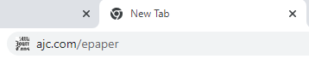

If the ePaper hasn’t been saved to your desktop/home screen, you can access by opening the browser of your choice and entering **ajc.com/epaper** in the address bar

**READING THE ATLANTA JOURNAL-CONSTITUTION ON YOUR DESKTOP/MOBILE DEVICE**

Once opened, you will see today’s edition centered, with prior editions below and additional publications listed at the top. Tap today’s edition to open it.

Tap an individual story to open in a larger window. To move to another page, swipe left or right, or tap the left and right arrows at the bottom of the screen. “Pinch” in or out on the screen to make the page smaller or larger. To exit to the main menu, tap the left arrow at the top.

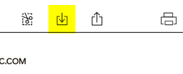

Tap the download symbol to download the paper if you want to read where WiFi is not available.

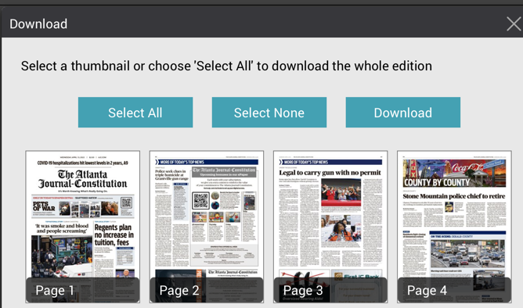

Choose Select All to download the entire paper, or you can tap individual pages to be more selective. Once your choice is made, tap Download to download.



To jump to your favorite section, tap on the page numbers in the bottom center of your screen, then tap on the desired section and then the page within that section.

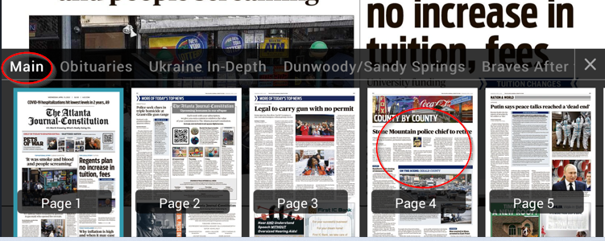

Back Issues are available from the main page. Simply tap on the image of the date you wish to view to open that edition. If you are searching farther back, tap on the calendar icon to go back to 2018.

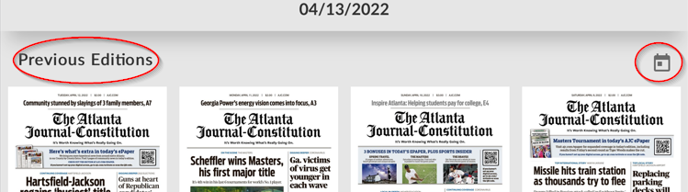

Also from the main page, you can browse our other digital editions by tapping your selection in the top menu.

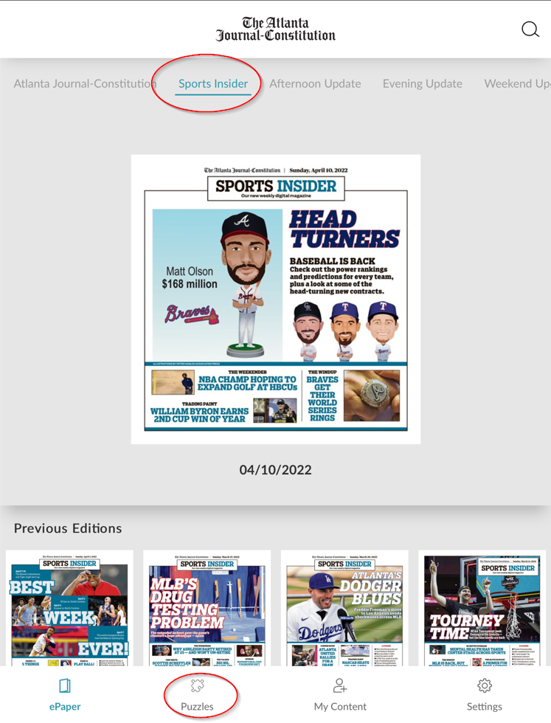

To explore all of our digital options or if you have any questions about how to use any of our digital products, take advantage of our helpful “how-to” articles at [ajc.com/help](https://ajc.zendesk.com/hc/en-us/articles/4412679410711-Welcome-to-Your-Digital-Access-).

And don’t forget the interactive puzzles along the bottom menu!

**CONNECTING TO WI-FI**

If off, toggle Wi-Fi on by tapping the button on the right.

Tap Settings, then tap Wi-Fi.

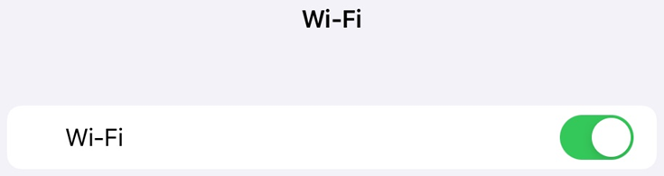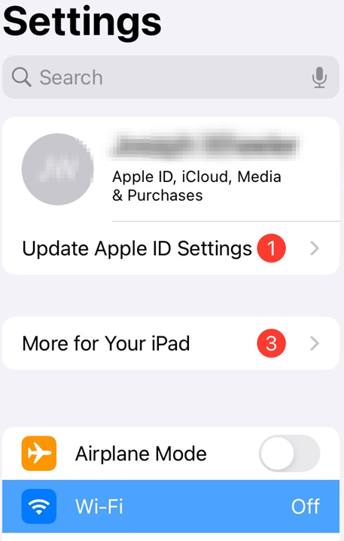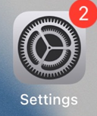

Under Networks, tap on your Wi-Fi name.

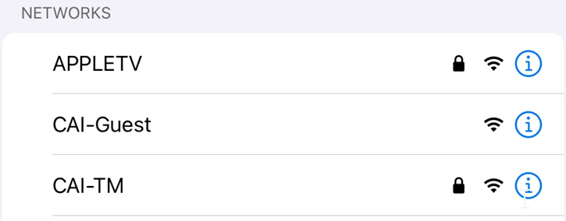

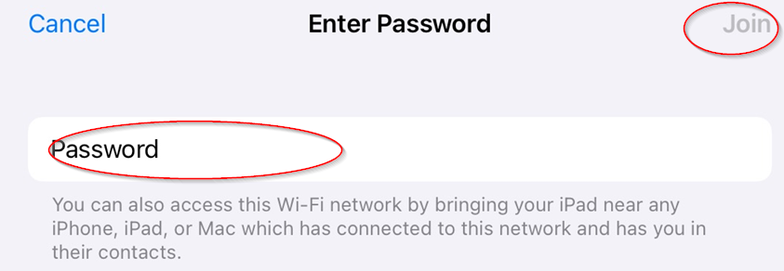

Enter your password and tap Join.

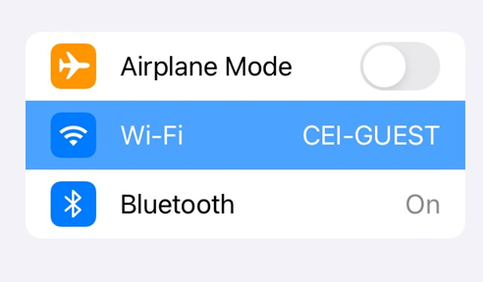

Once you are connected, the Wi-Fi name will appear to the right of the Wi-Fi location.